**Exercise 1**

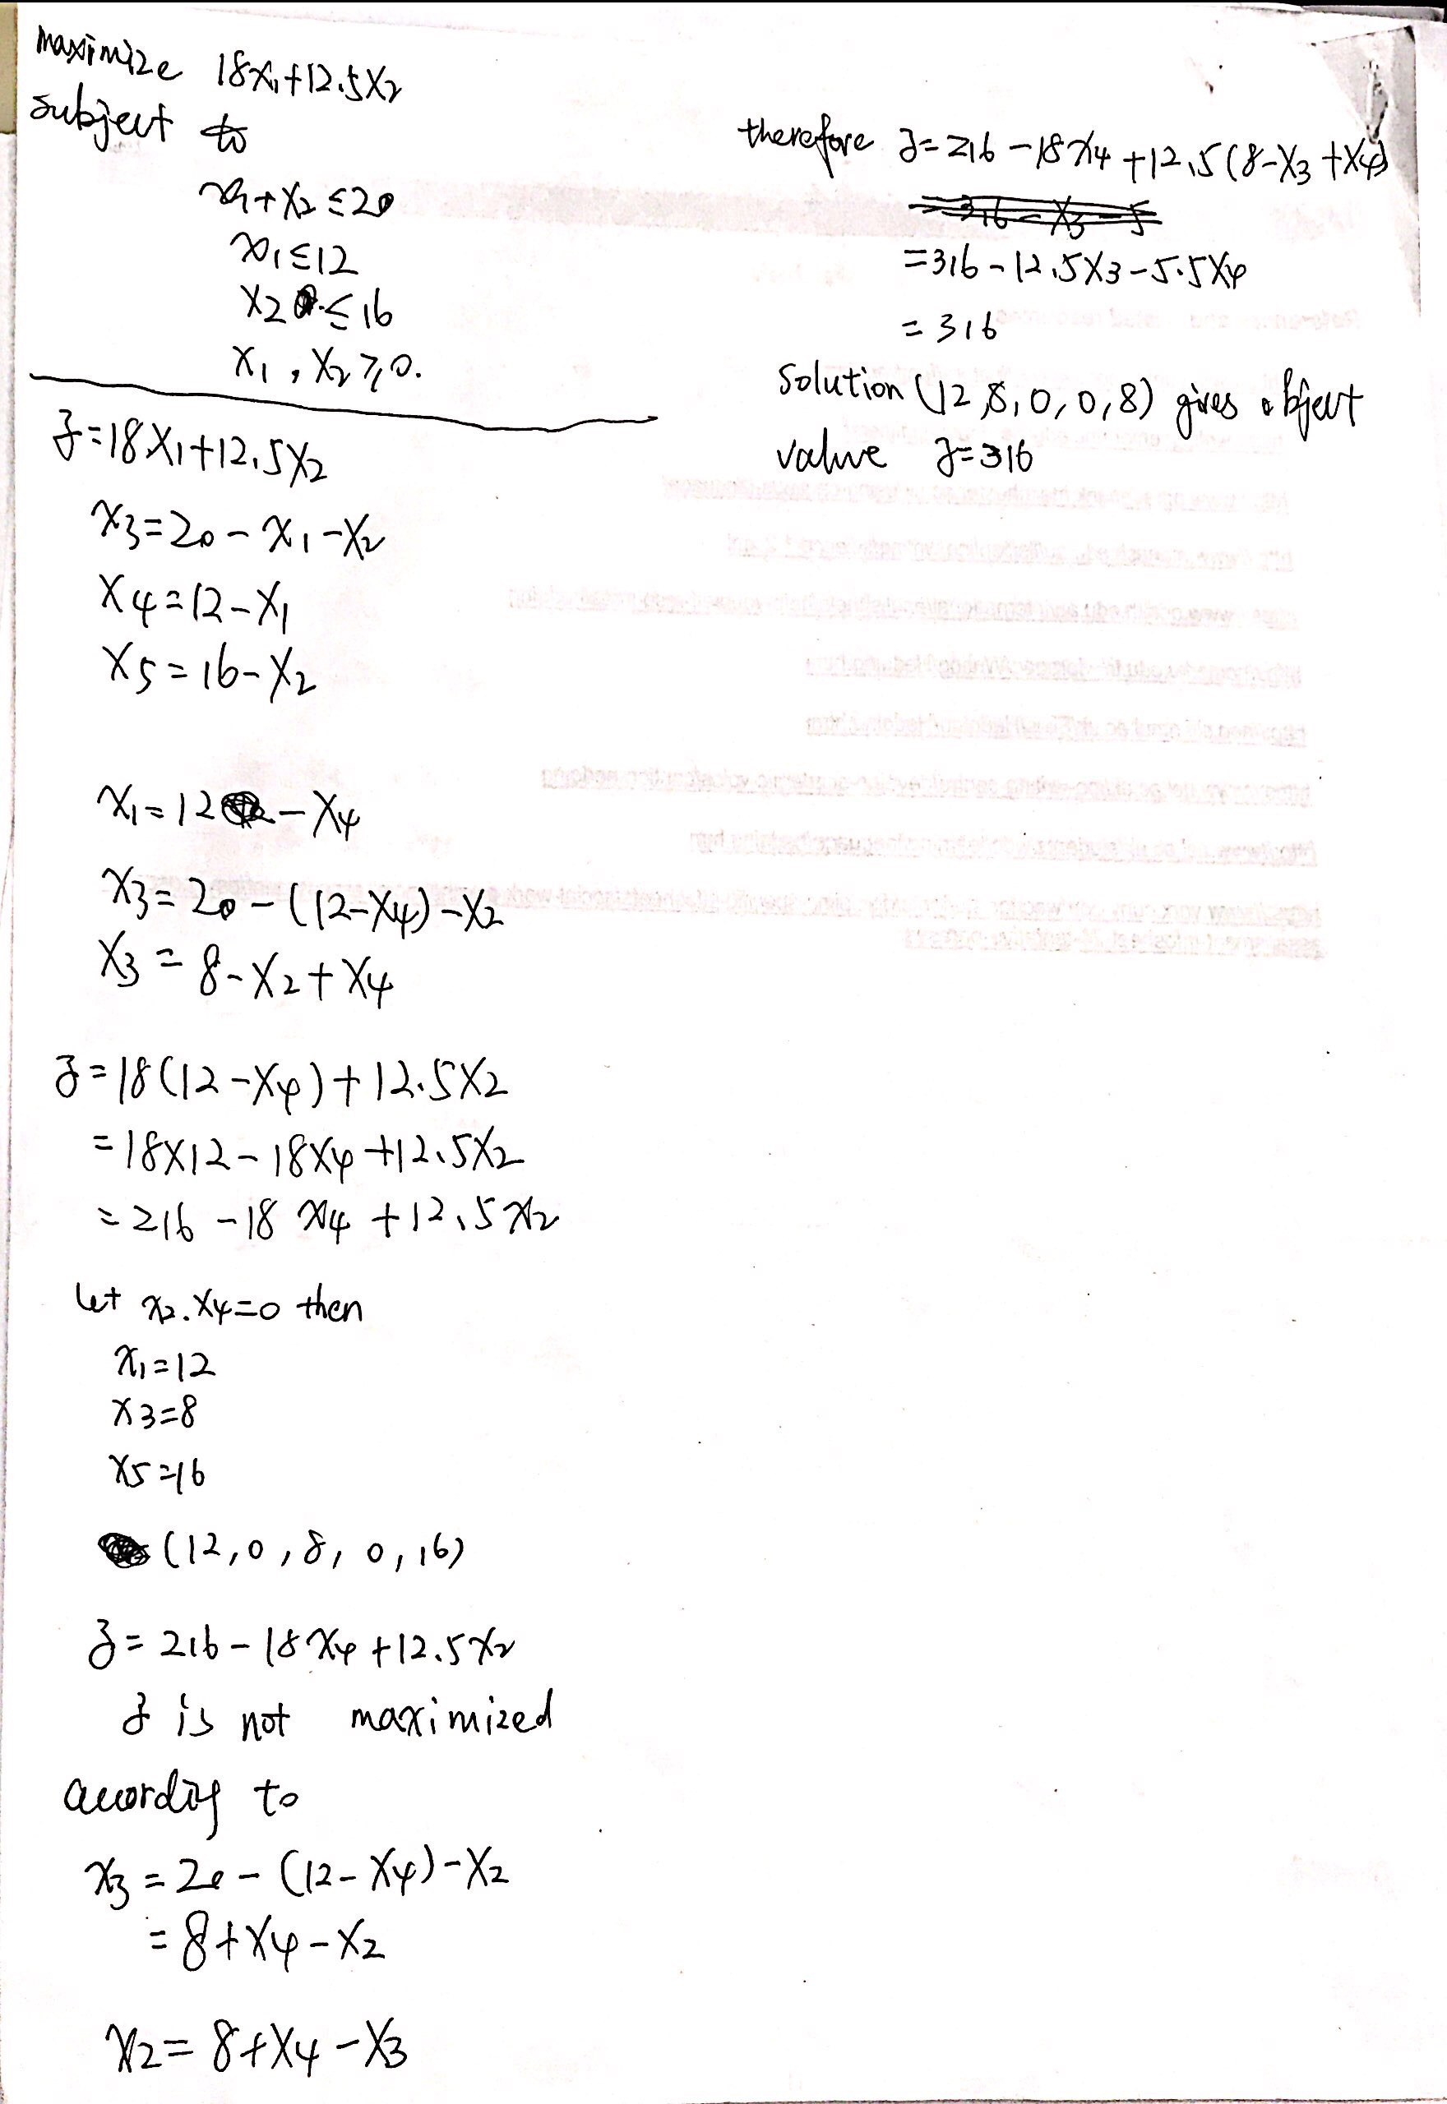

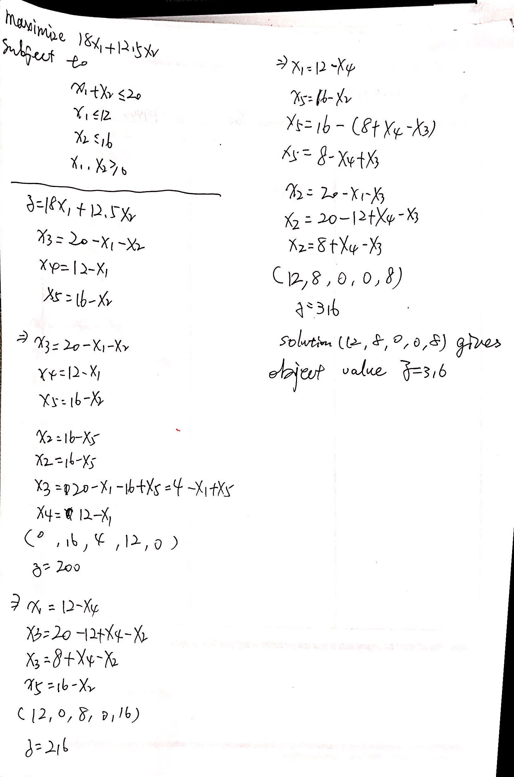

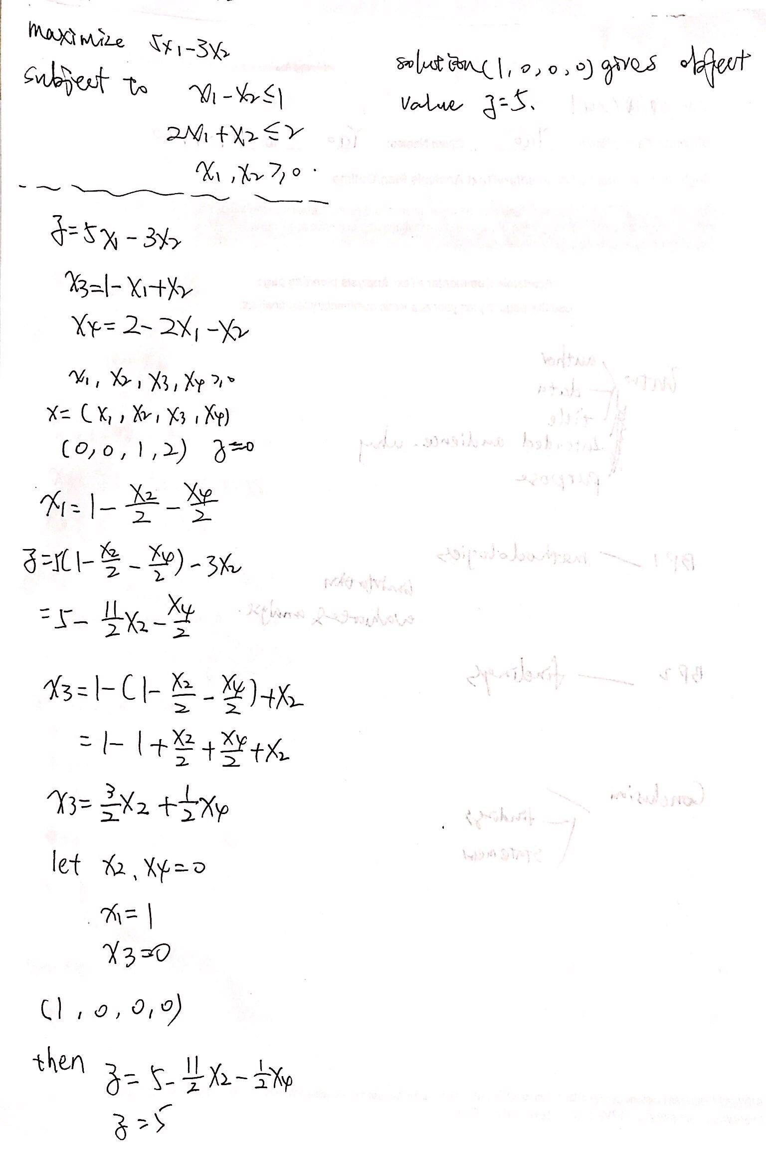

**Exercise 2**

1.

minimize. 20y1+12y2+16y3

subject to

y1+y2 >= 18

y1+y3 >= 12.5

y1, y2, y3 >= 0

（Three constraints, two variables become two constraints, three variables）

2.

minimize 8y1-3y2+2y3

subject to

y1-y2-y3 >= 1

-y1-y2+4y3 >= 3

y1, y2, y3 >= 0

**Exercise 3**

Idea：

Obj: A1S1+A2S2=….. AnSn

Maximize: obj

Constraints:

1. A1S1+A2S2=….. AnSn=G1(1-A1)+G2(1-A2)+….Gn(1-An)
2. 0<=Ai<=1 where 1 belong to {1,….,n}
3. 0<=Si<=100
4. 0<=Gi<=100
5. 1<=n<=50

input: S, G

Assert: 1<= length(S)<=50 and 1<= length(G)<=50 and

length(S)= length(G)

If length(S)==1

S1*p=(1-p)*G1

Else if length(S)>1

You take the maximum value of S, you mark it, you don't take it anymore.

Take the maximum in G, and remove the mark.

If max(S)> max(G)

I'm going to take the largest element of G that's left, and I'm going to keep doing that until I get to S, and then I'm going to get to the last element of G.

If sum(After S is taken)>sum(After G is taken)

Si*p=(1-p)*Gi-(sum(After S is taken))- (sum(After G is taken))

I used GMPL to obtain the objective equation and the constraint equation based on the above analysis, but only obtained the values in two examples.

Error: syntax error in expression. There is something special about the way GMPL is expressed.

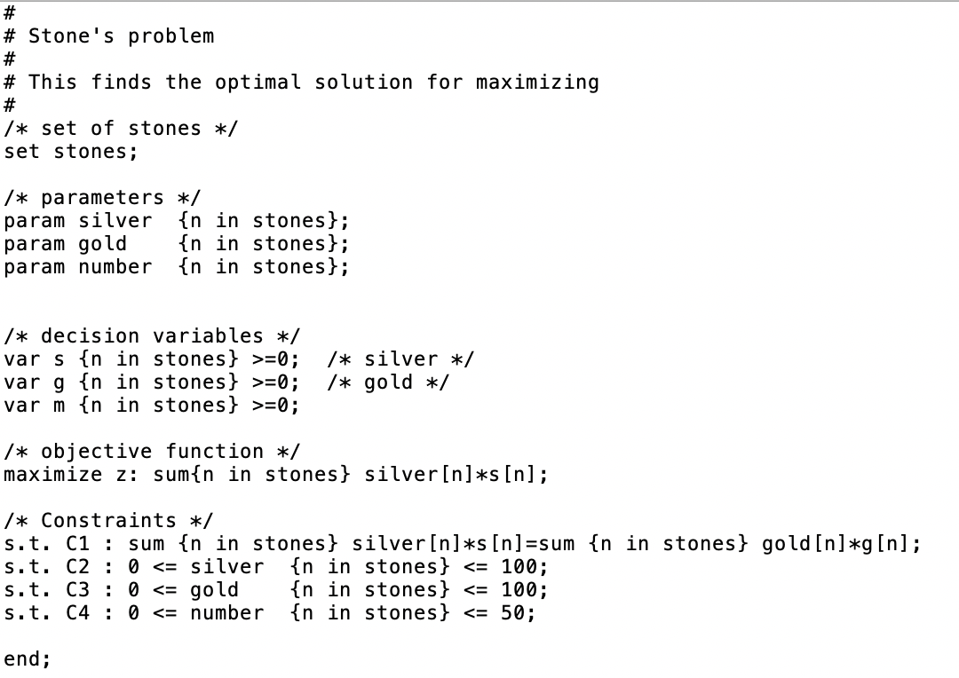

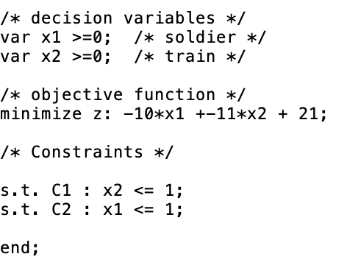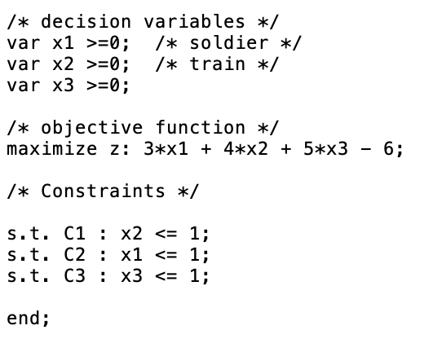

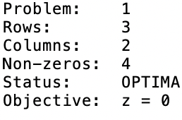

(example2.mod)

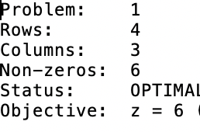

(example3.mod)

Another method is to use the genetic algorithm to get a new result, the new result and the original result comparison, the new result value is high, with the new result as collateral, if the original result value is high, still use the original result variation, stack 100 generations, to find the optimal solution.

